

CC-215-L: Database Systems Lab
Faculty of Computing & Information Technology

BS(IT&CS) Morning - Fall 2023
LAB – 10-ODD
The objective of this lab is to:
- Practice PL/SQL
Course & Lab Instructor: Dr. Asif Sohail
Task 01: [10 Marks]
- Write a PL/SQL program that takes an integer as input from the user and generates its multiplication table.
DECLARE
NUM NUMBER;
I NUMBER;
BEGIN
NUM:=:NUM;
FOR I IN 1..10
LOOP
DBMS_OUTPUT.PUT_LINE(NUM||'*'||I||'= '||NUM*I);
END LOOP;
END;
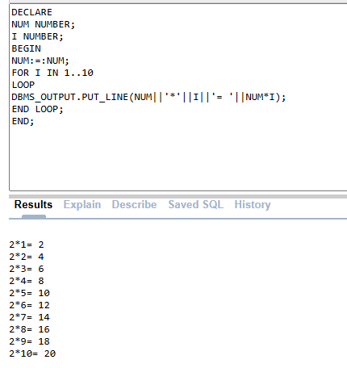
- Write a PL/SQL block that takes a number from the user as input and then checks if it is prime or not.
DECLARE
NUM NUMBER;
IS_PRIME NUMBER := 1;
BEGIN
NUM := :NUM;
IF NUM <= 1 THEN
DBMS_OUTPUT.PUT_LINE('NOT A PRIME');
RETURN;
END IF;
FOR I IN 2..FLOOR(SQRT(NUM))
LOOP
IF MOD(NUM, I) = 0 THEN
IS_PRIME := 0;
EXIT;
END IF;
END LOOP;
IF IS_PRIME = 1 THEN
DBMS_OUTPUT.PUT_LINE('IS PRIME');
ELSE
DBMS_OUTPUT.PUT_LINE('IS NOT PRIME');
END IF;
END;
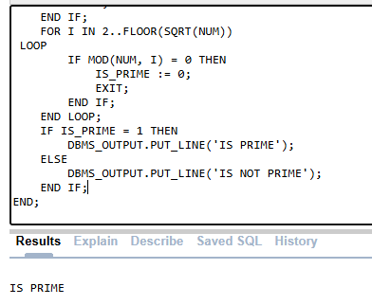
- Write a PL/SQL block that takes two strings from the user and checks the total occurrences of the first string in the second string.
DECLARE
STR1 VARCHAR2(100);
STR2 VARCHAR2(100);
COUNT1 NUMBER := 0;
BEGIN
STR1 := :STR1;
STR2 := :STR2;
FOR I IN 1..LENGTH(STR2) - LENGTH(STR1) + 1 LOOP
IF SUBSTR(STR2, I, LENGTH(STR1)) = STR1 THEN
COUNT1 := COUNT1 + 1;
END IF;
END LOOP;
DBMS_OUTPUT.PUT_LINE(STR1 || ' APPEARS ' || COUNT1 || ' TIMES IN STR2');
END;
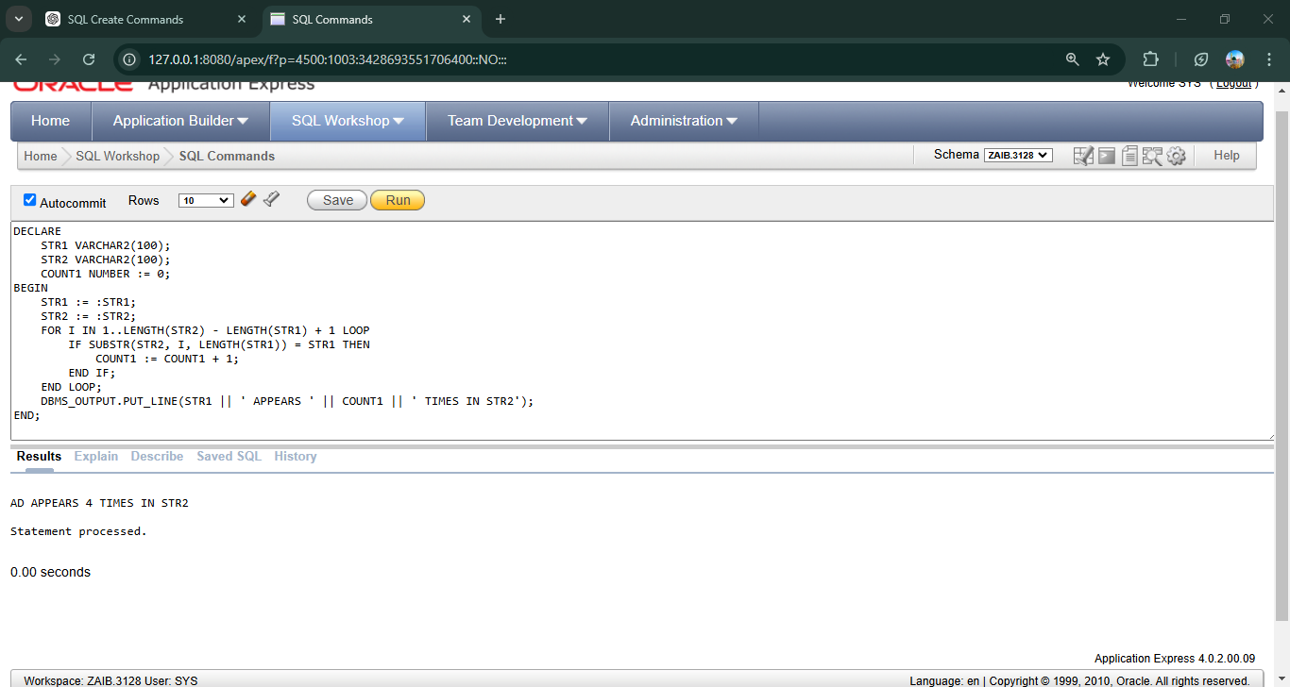
- Write a PL/SQL program that takes an integer as input from the user and calculates the product of its digits.
DECLARE
NUM NUMBER;
PRO NUMBER:=1;
BEGIN
NUM:=:NUM;
WHILE NUM > 0
LOOP
PRO:=PRO* (NUM MOD 10);
NUM:= TRUNC(NUM/10);
END LOOP;
DBMS_OUTPUT.PUT_LINE('PRODUCT IS '||PRO);
END;
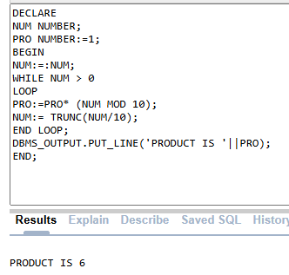
- Write a PL/SQL block that finds the square root of a number. In case of imperfect squares, display the floor value. (Use of sqrt function is not allowed)
DECLARE
NUM NUMBER;
SRT NUMBER;
BEGIN
NUM:=:NUM;
SRT:=FLOOR(NUM ** 0.5);
DBMS_OUTPUT.PUT_LINE('SQRT IS '||SRT);
END;
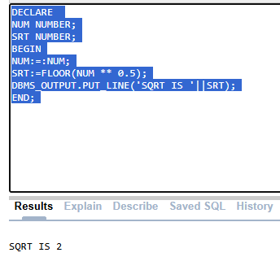

Task 02: [10 Marks]
      - Write a PL/SQL block that calculates and displays the total salary expenditure of each department.
DECLARE
CURSOR C_DEPT_SAL IS SELECT DEPTNO,SUM(SAL) AS TOTAL_SAL
FROM EMP
GROUP BY DEPTNO;
V_DEPT_SAL C_DEPT_SAL%ROWTYPE;
BEGIN
OPEN C_DEPT_SAL;
LOOP
FETCH C_DEPT_SAL INTO V_DEPT_SAL;
EXIT WHEN C_DEPT_SAL%NOTFOUND;
DBMS_OUTPUT.PUT_LINE('DEPARTMENT '||V_DEPT_SAL.DEPTNO ||' HAS EXPENDITURE OF '||V_DEPT_SAL.TOTAL_SAL);
END LOOP;
CLOSE C_DEPT_SAL;
END;
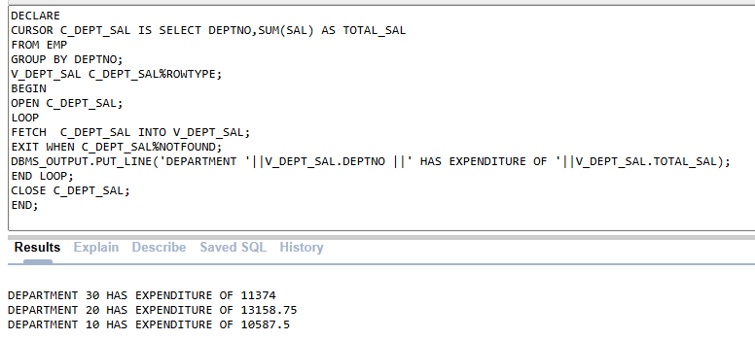
- Write a PL/SQL Block that takes two employee’s names as input and swaps their salaries in the table. (Make sure to handle Exception)
DECLARE
V_SAL1 EMP.SAL%TYPE;
V_SAL2 EMP.SAL%TYPE;
V_EMP1 VARCHAR2(100):=:EMP1;
V_EMP2 VARCHAR2(100):=:EMP2;
BEGIN
SELECT SAL INTO V_SAL1
FROM EMP;
WHERE ENAME = V_EMP1;
SELECT SAL INTO V_SAL2
FROM EMP;
WHERE ENAME = V_EMP2;
UPDATE EMP
SET SAL = V_SAL2
WHERE ENAME = V_EMP1;
UPDATE EMP
SET SAL = V_SAL1
WHERE ENAME = V_EMP2;
DBMS_OUTPUT.PUT_LINE('SAL UPDATED!!');
EXCEPTION
WHEN NO_DATA_FOUND THEN
DBMS_OUTPUT.PUT_LINE('One or both employees not found');
END;
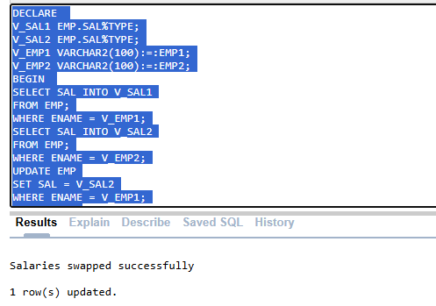
- Write a PL/SQL block to display the top 3 highest-paid employees along with their salary and rank.
DECLARE
V_NAME EMP.ENAME%TYPE;
V_SAL EMP.SAL%TYPE;
V_JOB EMP.JOB%TYPE;
V_SAL1 EMP.SAL%TYPE;
V_SAL2 EMP.SAL%TYPE;
V_SAL3 EMP.SAL%TYPE;
BEGIN
SELECT MAX(SAL) INTO V_SAL1 FROM EMP;
SELECT MAX(SAL) INTO V_SAL2 FROM EMP WHERE SAL < (SELECT MAX(SAL) FROM EMP);
SELECT MAX(SAL) INTO V_SAL3 FROM EMP WHERE SAL < (SELECT MAX(SAL) FROM EMP WHERE SAL < (SELECT MAX(SAL)FROM EMP));
FOR I IN 1..3
LOOP
IF I=1 THEN
DBMS_OUTPUT.PUT_LINE('HIGHEST '||V_SAL1);
ELSIF I=2 THEN
DBMS_OUTPUT.PUT_LINE('2ND HIGHEST '||V_SAL2);
ELSE
DBMS_OUTPUT.PUT_LINE('LOWEST '||V_SAL3);
END IF;
END LOOP;
END;
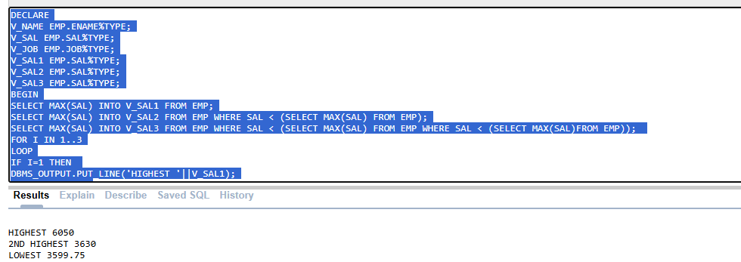

- The salary of an employee is to be raised by 15% annually of his/her current salary. Write a PL/SQL program that takes empno as input, retrieves sal of that employee and projects the salary for the next five years. The output of the program should be like:
Current Salary: 800
Salary after year 1: 920
Salary after year 2: 1058
Salary after year 3: 1216
Salary after year 4: 1399
Salary after year 5: 1609
DECLARE
V_EMPNO EMP.EMPNO%TYPE;
V_SAL EMP.EMPNO%TYPE;
NEW_SAL NUMBER;
BEGIN
V_EMPNO:=:V_EMPNO;
SELECT SAL INTO V_SAL FROM EMP
WHERE V_EMPNO=EMPNO;
DBMS_OUTPUT.PUT_LINE('CURRENT SAL = '||V_SAL);
NEW_SAL:=V_SAL;
FOR I IN 1..5
LOOP
NEW_SAL:=NEW_SAL+ROUND(NEW_SAL*0.15);
DBMS_OUTPUT.PUT_LINE('SAL AFTER '||I||' YEARS IS '||NEW_SAL);
END LOOP;
END;
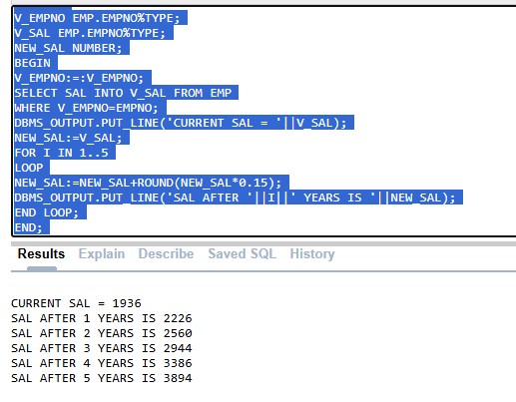
- Develop a PL/SQL block that displays the details of the three highest-paid employees. (DON’T USE CURSOR)
declare
v_ename emp.ename%type;
v_sal emp.sal%type;
v_job emp.job%type;
v_sal1 emp.sal%type;
v_sal2 emp.sal%type;
v_sal3 emp.sal%type;
begin
select max(sal) into v_sal1 from emp;
select max(sal) into v_sal2 from emp where sal < (select max(sal)
from emp);
select max(sal) into v_sal3 from emp where sal < (select max(sal)
from emp where sal < (select max(sal) from emp));
for i in 1..3 loop
if i = 1 then
dbms_output.put_line('details of employee with the highest
salary:');
select ename, sal, job into v_ename, v_sal, v_job from emp
where sal = v_sal1 and rownum=1;
dbms_output.put_line('Employee Name: ' || v_ename || ',
Salary: ' || v_sal || ', Job: ' || v_job);
elsif i = 2 then
dbms_output.put_line('details of employee with the second
highest salary:');
select ename, sal, job into v_ename, v_sal, v_job from emp
where sal = v_sal2 and rownum=1;
dbms_output.put_line('Employee Name: ' || v_ename || ',
Salary: ' || v_sal || ', Job: ' || v_job);
else
dbms_output.put_line('details of employee with the third
highest salary:');
select ename, sal, job into v_ename, v_sal, v_job from emp
where sal = v_sal3 and rownum=1;
dbms_output.put_line('Employee Name: ' || v_ename || ',
Salary: ' || v_sal || ', Job: ' || v_job);
end if;
end loop;
end;
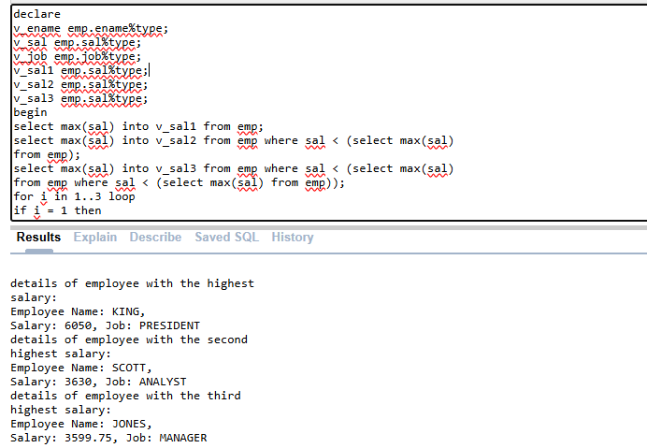

Task 03: [10 Marks]
1. Write a PL/SQL program that uses a cursor to calculate and display the total bonus allocated for each department based on employees' salaries. The bonus is calculated as 20% of the salary for employees with salaries above the department average, and 10% for others. Use a nested cursor to fetch employee details for each department and display their bonuses along with a department-wise total.
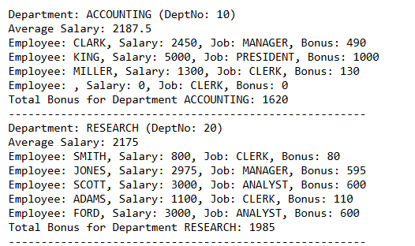
DECLARE
CURSOR DEPT_CURSOR IS
SELECT DEPTNO,DNAME FROM DEPT;
V_DEPTNO DEPT.DEPTNO%TYPE;
V_DNAME DEPT.DNAME%TYPE;
V_TOTAL NUMBER:=0;
CURSOR EMP_CURSOR IS
SELECT E.ENAME,E.SAL,E.JOB
FROM EMP E
WHERE E.DEPTNO = V_DEPTNO;
V_ENAME EMP.ENAME%TYPE;
V_SAL EMP.SAL%TYPE;
V_JOB EMP.JOB%TYPE;
V_DEPT_SAL NUMBER;
V_BONUS NUMBER;
BEGIN
OPEN DEPT_CURSOR;
LOOP
FETCH DEPT_CURSOR INTO V_DEPTNO ,V_DNAME;
EXIT WHEN DEPT_CURSOR%NOTFOUND;
SELECT AVG(SAL) INTO V_DEPT_SAL FROM EMP
WHERE V_DEPTNO = DEPTNO;
DBMS_OUTPUT.PUT_LINE('DEPARTMENT : '||V_DNAME||' (DEPTNO : ' ||V_DEPTNO||')');
DBMS_OUTPUT.PUT_LINE('AVERAGE SAL : '||V_DEPT_SAL);
OPEN EMP_CURSOR;
LOOP
FETCH EMP_CURSOR INTO V_ENAME,V_SAL,V_JOB;
EXIT WHEN EMP_CURSOR%NOTFOUND;
IF V_SAL > V_DEPT_SAL THEN
V_BONUS:=V_SAL*0.2;
ELSE
V_BONUS:=V_SAL*0.1;
END IF;
V_TOTAL:=V_TOTAL+V_BONUS;
DBMS_OUTPUT.PUT_LINE('EMPLOYEE: '||V_ENAME||', SALARY : '||V_SAL||', JOB : '||V_JOB||', BONUS: '||V_BONUS);
END LOOP;
DBMS_OUTPUT.PUT_LINE('TOTAL BONUS FOR DEPARTMENT '||V_DNAME||': '||V_TOTAL);
DBMS_OUTPUT.PUT_LINE('---------------------------------------');
CLOSE EMP_CURSOR;
END LOOP;
CLOSE DEPT_CURSOR;
END;
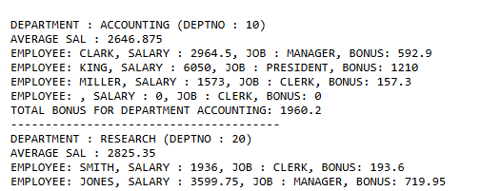
2. Develop a PL/SQL block that generates a pattern of stars (*) based on the employee's salary. For each thousand dollars in salary, display a star. For instance, if an employee earns $2500, display two stars.
DECLARE
V_SAL EMP.SAL%TYPE;
STAR VARCHAR2(20);
V_SNUM NUMBER;
BEGIN
SELECT SAL INTO V_SAL FROM EMP
WHERE EMPNO =:EMPNO;
V_SNUM :=TRUNC(V_SAL/1000);
FOR I IN 1.. V_SNUM
LOOP
STAR:=STAR||'*';
END LOOP;
DBMS_OUTPUT.PUT_LINE('STARS ON SAL '|| STAR);
END;
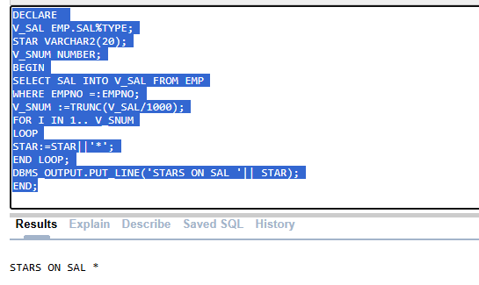
Task 04: _________________[5 Marks]
VIVA VOCE

